LC#83REMOVE DUPLICATES FROM SORTED LIST
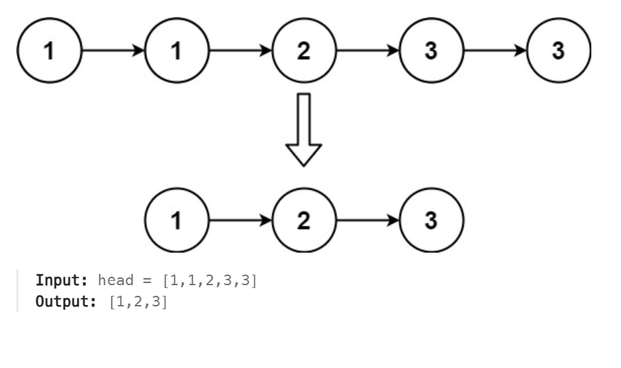

APPROACH:
->take dummy node and traverse
->check the current and the next node are !=null
->if both values are same move the next -> next.next
->else move .next only
CODE:
class Solution {
public ListNode deleteDuplicates(ListNode head) {
ListNode dummy = head;
while(dummy!=null && dummy.next !=null)
{
if(dummy.val==dummy.next.val)
dummy.next = dummy.next.next;
else
dummy= dummy.next;
}
return head;}}
LC#82 REMOVE FROM SORTED LIST II
APP: TC:O(N) SC:O(1)
->get a copy and proceed
->use two loops one for pointer change and other for dup check
->update dup accordingly and pointer

class Solution {
public ListNode deleteDuplicates(ListNode head) {
ListNode dummy = new ListNode(0);
dummy.next = head;
ListNode prev = dummy;
while(head!=null)
{
boolean dup = false;
while(head.next!=null && head.val==head.next.val)
{
dup = true;
head = head.next;
}
if(dup)
prev.next = head.next;
else
prev = prev.next;
head = head.next;
}
return dummy.next;

}}
LC#206 REVERSE A LINKED LIST:
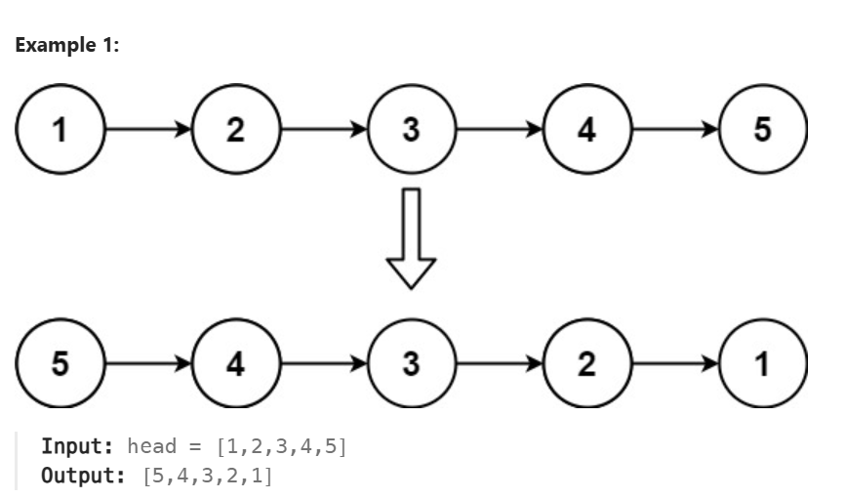
class Solution {
public ListNode reverseList(ListNode head) {
ListNode prev = null;
ListNode curr = head;
while(curr!=null)
{
ListNode nextNode = curr.next;
curr.next = prev;
prev = curr;
curr = nextNode;

}
return prev;
}
}

LC#92 REVERSE A LINKED BETWEEN INTERVALS
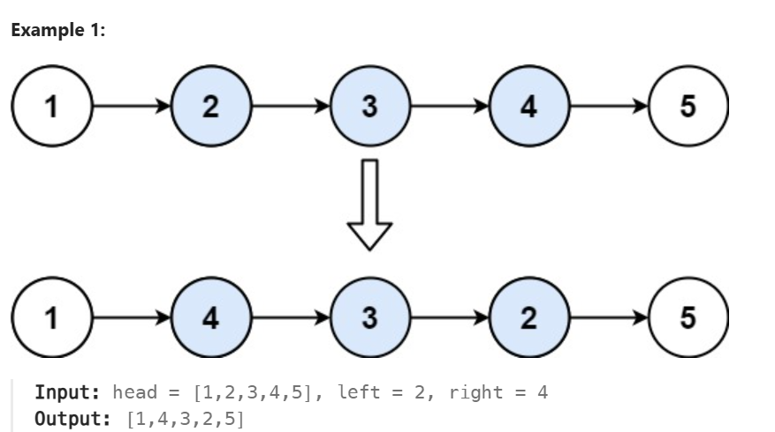
APPROACH:
- Firstly traverse before the left point & also store the starting of the left node
- Then reverse logic
- Then point reversed list(prev) to left => left.next = prev
- Now the rev left node is in right side so it next side will be => tail.next = curr
- Return the dummy
APP1:BREAK CHAIN
class Solution {
public ListNode reverseBetween(ListNode head, int left, int right) {
if(head==null || head.next==null || left ==right)
return head;
ListNode dummy = new ListNode(-1);
dummy.next = head;
ListNode prev = dummy;
for(int i =1 ; i<left ;i++)
prev = prev.next;
ListNode start = prev.next;//rev start node
ListNode end = start;
for(int i = left;i<right;i++)
end = end.next;
ListNode rem = end.next;
end.next =null;
ListNode rev = revNode(start);
prev.next = rev;
start.next = rem;
return dummy.next;
}
public ListNode revNode(ListNode head)
{
ListNode curr = head;
ListNode prev = null;
while(curr!=null)
{
ListNode nn = curr.next;
curr.next = prev;
prev = curr;
curr = nn;
}
return prev;
}
}

APP2: no braking
class Solution {
public ListNode reverseBetween(ListNode head, int left, int right) {
if (head == null || left == right) return head;
ListNode dummy = new ListNode(0);
dummy.next = head;

ListNode leftPrev = dummy;
for (int i = 1; i < left; i++) {
leftPrev = leftPrev.next;
}

ListNode start = leftPrev.next;
ListNode after = start;
for (int i = left; i <= right; i++) {
after = after.next;
}
ListNode reversedHead = reverseK(start, right - left + 1);
leftPrev.next = reversedHead;
start.next = after;
return dummy.next;
}
private ListNode reverseK(ListNode head, int k) {
ListNode prev = null;
ListNode curr = head;
while (k-- > 0) {
ListNode nextNode = curr.next;
curr.next = prev;
prev = curr;
curr = nextNode;
}
return prev;}}
LC#234 PALIDROME LINKED LIST
APP:
->find the middle element using fast and slow pointer approach
->reverse the second half and compare it with the first half
->copying the data to another ds and comparing takes O(n) this app is O(1) in memory
class Solution {
public boolean isPalindrome(ListNode head) {
if (head == null || head.next == null) return true;
ListNode fast = head, slow = head;
while(fast.next!=null && fast.next.next!=null)
{
slow = slow.next;
fast = fast.next.next;
}
ListNode prev =null;
ListNode firsthalf = head;
ListNode curr =slow.next;

while(curr!=null)
{
ListNode nn = curr.next;
curr.next = prev;
prev = curr;
curr = nn;
}

while(prev!=null)
{
if(prev.val!=firsthalf.val)
return false;
firsthalf = firsthalf.next;
prev = prev.next;
}
return true;

}
}

LC#25 REV LINKED LIST BY K NODE
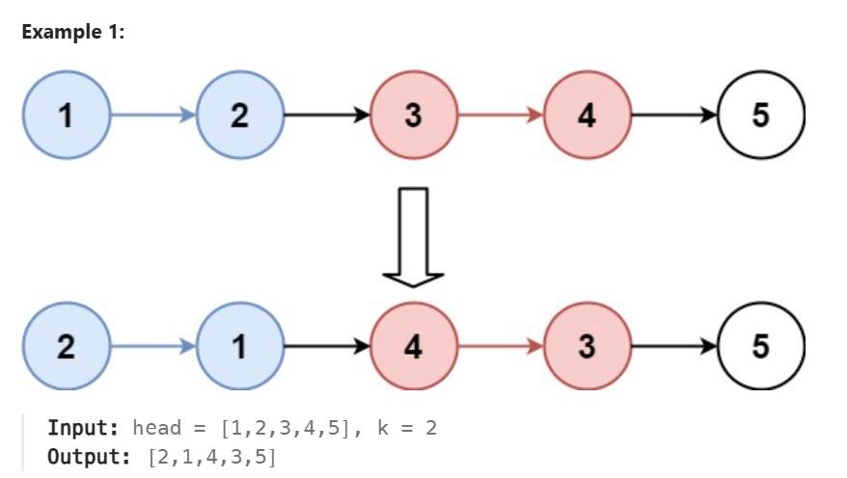APPROACH:
->write the reverse function separately
->prevGroup nextGroup two lists
->prevGroup point to the starting of the every kth node and we kinda break it and then reverse

CODE:
class Solution {
public ListNode reverseKGroup(ListNode head, int k) {
ListNode dummy = new ListNode(0);
dummy.next = head;
ListNode prevGrp = dummy;
ListNode curr = head;
while(true)
{
ListNode kth = kthNode(curr, k);
if(kth==null)
break;
ListNode nxtGrp = kth.next;//backup of next grp
kth.next = null;
ListNode rev = revNode(curr);

prevGrp.next = rev;
curr.next = nxtGrp;

prevGrp = curr;
curr = nxtGrp;
}
return dummy.next;
}

public ListNode kthNode(ListNode head , int k )
{
while(head!=null && k>1)
{
head = head.next;
k--;
}
return head;
}

public ListNode revNode(ListNode head)
{
ListNode prev = null , curr = head;
while(curr!=null)
{
ListNode nn =curr.next ;
curr.next = prev;
prev = curr;
curr = nn;
}
return prev;
}
}

